*I PHONE mobile*

IPHONE 15 PRO MAX

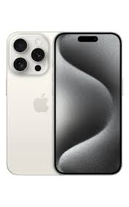

iPhone 15 Technical Specifications · **12MP camera** · ƒ/1.9 aperture · Autofocus with Focus Pixels · Retina Flash · Photonic Engine · Deep Fusion · Smart HDR 5 · Next- ...

**PRICE /**  10,000,000 **PRK**